Multimedia Web Design Homework
HTML EXERCISES (week 2)

Eda Selmani – Computer Engineering

Exercise 1: Create your HTML file
Open a plain text editor (Notepad on Windows, TextEdit on Mac set to plain text, or VS Code). Type out the basic HTML structure above by hand — don't copy/paste! Save the file as index.html. Then open it in your browser by double-clicking the file. You should see the tab title say 'My Website' and the words 'Hello, World!' on the page.

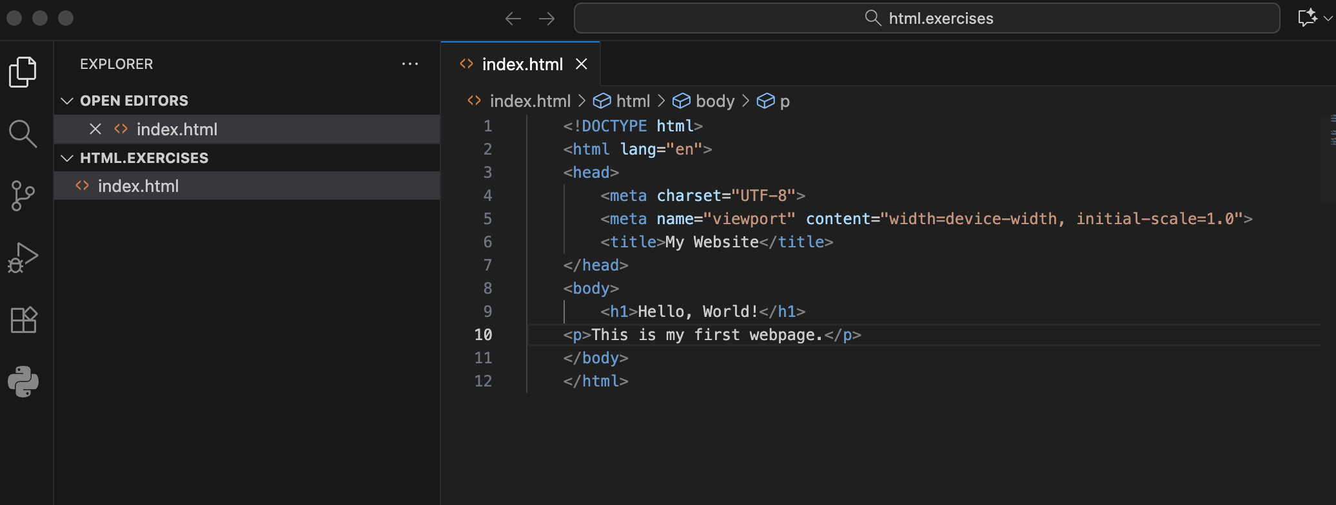

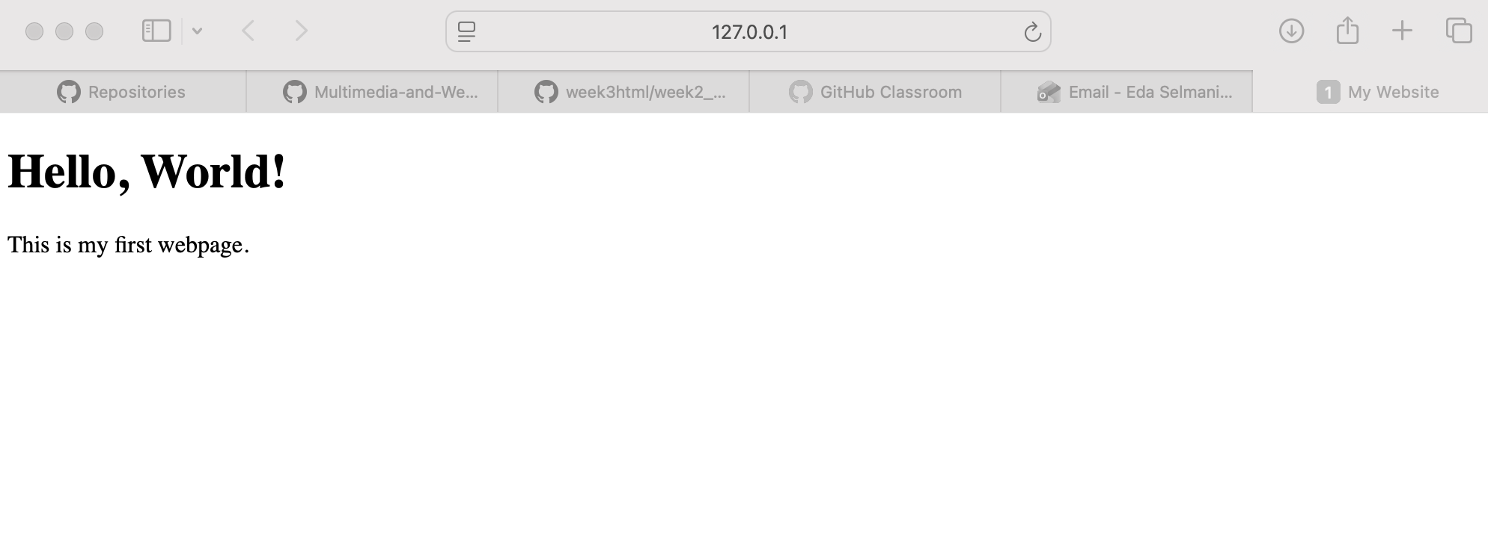

Exercise 2: Build the Text Content of your Website
We are building a PERSONAL PORTFOLIO website over the 3 weeks. Open your index.html file. Inside the <body>, add: (1) An <h1> with your name as the main title. (2) An <h2> that says 'About Me'. (3) A <p> tag with 2-3 sentences describing yourself. (4) Use <strong> on at least one word and <em> on another. (5) Add an <hr> tag after your About section. Save and refresh your browser — you should see your content taking shape!

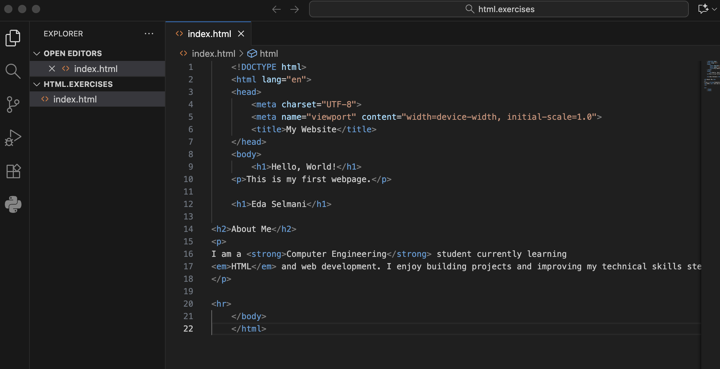

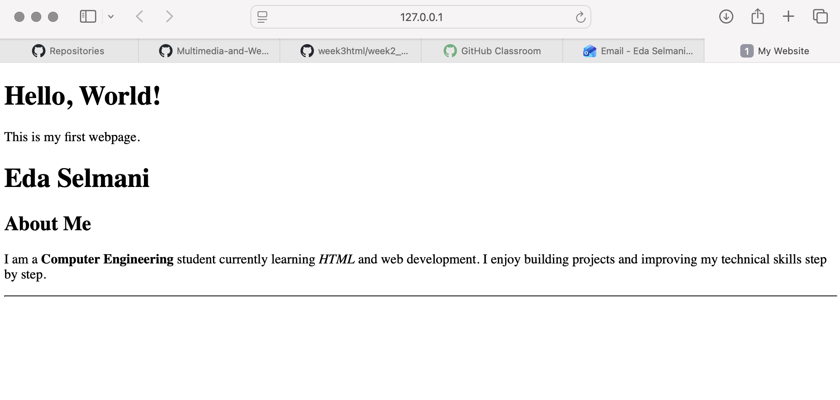

Exercise 3: Add lists to your portfolio
Continue working on your index.html. After your About Me section, add: (1) An <h2> heading called 'My Skills'. (2) An unordered list (<ul>) with at least 4 skills you have or want to learn. (3) An <h2> heading called 'How I Learn HTML'. (4) An ordered list (<ol>) with 4-5 steps you follow when learning (e.g., read the lesson, try the exercise, etc.). Your page is growing — save and refresh to see the results!
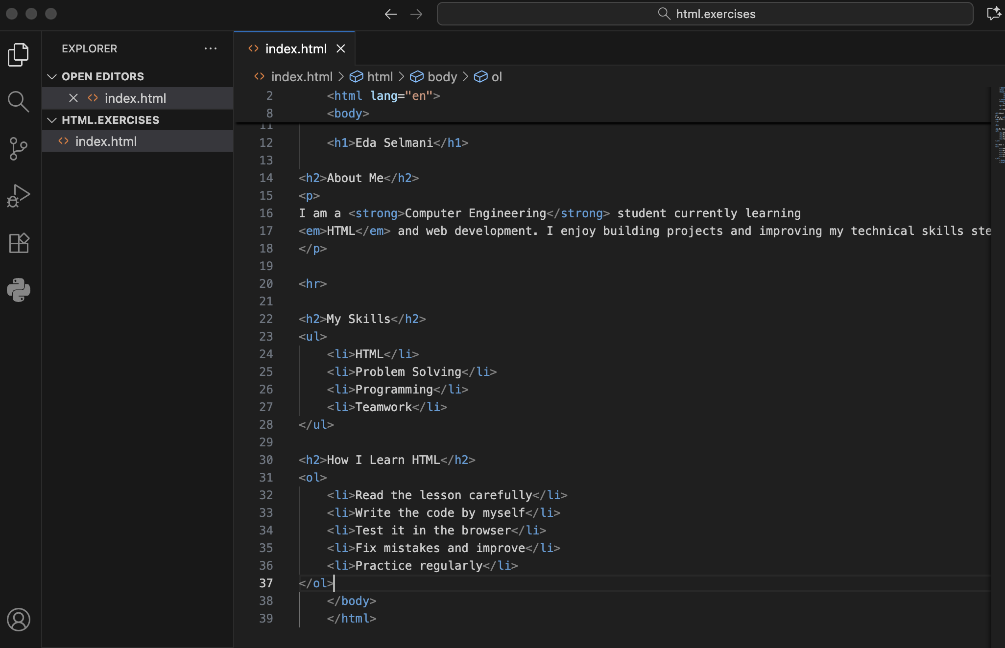

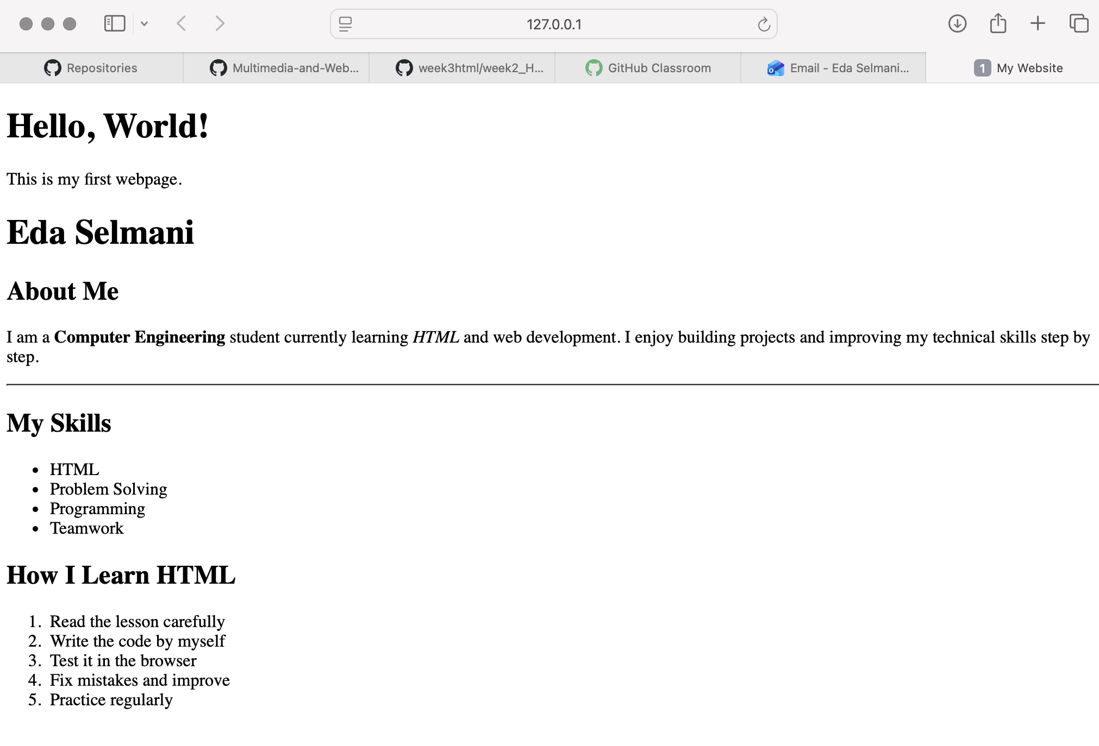
Exercise 4: Add links and an image to your portfolio
In your index.html: (1) Add an <h2> called 'Connect With Me'. (2) Add at least 3 links — one to your favorite website, one with target='_blank', and one mailto: link. (3) Find a free profile photo online OR use any image URL. Add it near your name at the top with a proper alt text. (4) Try setting the width attribute on your image to 150. Bonus: Try making an image a clickable link by putting an <img> tag inside an <a> tag!

